
FURTHER MATHEMATICS
TRIAL EXAMINATION 2
SOLUTIONS
2014

___________________________________________________________________

Core - solutions

Question 1 (2 marks)

- There are 264 pieces of data. The middle piece of data occurs between the 132nd and 133rd pieces of data. The median occurs therefore in the “often” category.
(1 mark)
- There are 46 members in the “sometimes” category and 62 in the “often” category.
So 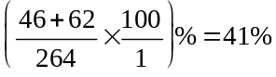 (correct to the nearest whole percentage).
(1 mark)

Question 2 (3 marks)

- i. The mode is the most frequently occurring piece of data.
(1 mark)

- 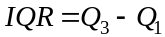
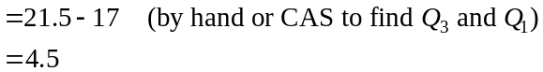
(1 mark)
- 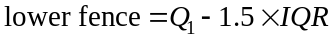
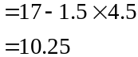
Since , the junior member with a GAT of 10 is an outlier for this group of junior members.
(1 mark)
Question 3 (6 marks)

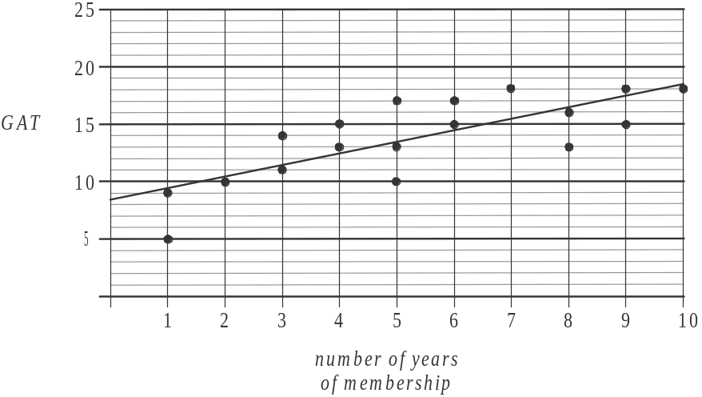

(1 mark)
(1 mark)
- i. The coefficient of determination tells us that 59.26% of the variation in the GAT can be explained by the variation in the number of years of membership.
(1 mark)
  - Since 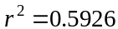
(1 mark)
- i.
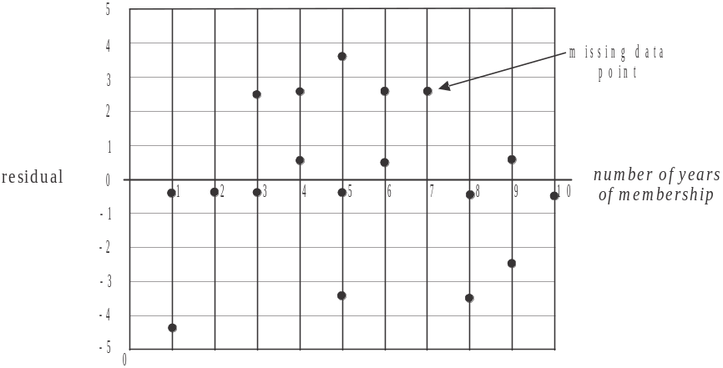

(1 mark)
    - The residual plot shows no clear pattern in the residuals. They appear to be randomly scattered around the zero residual line.
This supports our assumption that the relationship between the variables is linear.
(1 mark)

Question 4 (4 marks)

- The data shows cyclical variation (over 5 yearly cycles) as well as an overall increasing trend.
(1 mark)
- i. The trend line passes through the points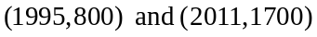.
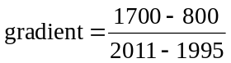
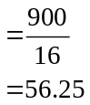
So the annual increase in the number of memberships sold is 56 (to the nearest whole number).
(1 mark)
  - For 8 of the years, the trend line overestimates the actual number of memberships sold.
(1 mark)
- On the time-series plot, find the median of the 2001, 2002, 2003, 2004 and 2005 data values. Those data values are, respectively, 1000, 1100, 1500, 1400 and 1200.
The median is 1200 so the smoothed value for 2003 is 1200.
(1 mark)
Module 1: Number patterns

Question 1 (3 marks)
(1 mark)
- Method 1 – generate the sequence on your calculator
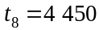
(1 mark)
Method 2 – using the formula
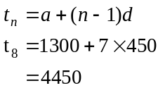
(1 mark)
- 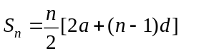 (formula sheet)
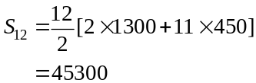
(1 mark)

Question 2 (4 marks)

- i. 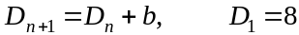
We’re told that 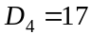
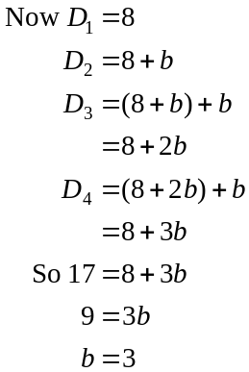
(1 mark)

- Because there is a common difference (of 3) between each term, the sequence is arithmetic. (1 mark)

- i. The equation 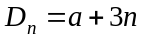 is not a difference equation.
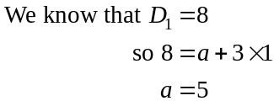
(1 mark)
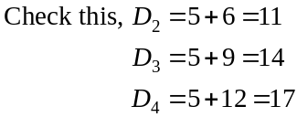
  - 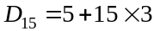
There are 50 drivers expected to be working in the 15th week. (1 mark)
Question 3 (2 marks)

- The Fibonacci sequence is given by 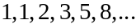
So, in the third week of operation there are 2 vans predicted to be needed.
(1 mark)

- If there are 26 drivers, and 2 drivers per van, there must be 13 vans.
Using the sequence 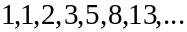 we see that this occurs in the 7th week of operation.
(1 mark)

Question 4 (3 marks)

- 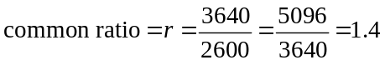 (1 mark)

- Use your calculator to generate the sequence
During the 6th week the amount of produce purchased will first exceed 10 000kg.
(1 mark)

- For a geometric sequence, the sum of n terms is given by
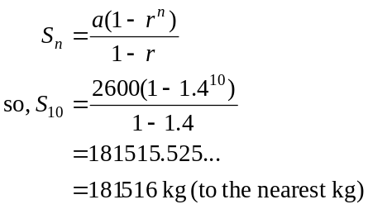
(formula sheet)
(1 mark)

Question 5 (3 marks)

- 
Note that you must give the equation AND the value of one term when defining a difference equation.
(1 mark)

- From part a. we have the number of deliveries made each week. We can calculate the average profit per delivery for each week of operation. We multiply these two values to find the total profit for the week.
Week | Number of deliveries | Average profit per delivery | Total profit made in a week
1 | 500 | $20 | 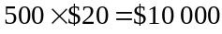
2 | 700 | $21 | 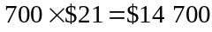
3 | 900 | $22.05 | 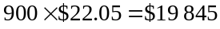
4 | 1100 | $23.15 | 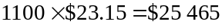
5 | 1300 | $24.31 | 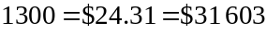

So after week 5 the business will move to the next stage of its expansion.
(1 mark) – generating the geometric sequence for average profit
(1 mark) – correct answer

Module 2: Geometry and trigonometry

Question 1 (4 marks)

- From the diagram, angle 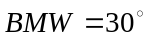 (alternate angles in parallel lines).
(1 mark)

- Using the right angled triangle shown,
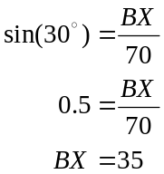
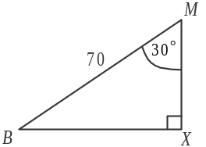
Point B is 35m west of the milk bar.
(1 mark)

- From the diagram, the bearing of point B from the milk bar is 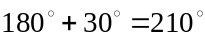.
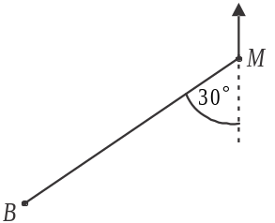
(1 mark)

- In ,
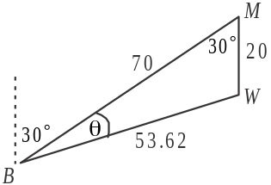
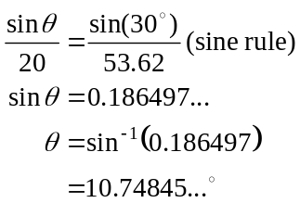
The bearing of the water tank from point B is 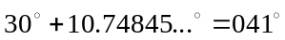 to the nearest whole degree.
(1 mark)

Question 2 (2 marks)

- circumference of a circle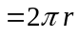 (formula sheet)
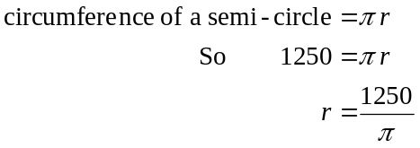
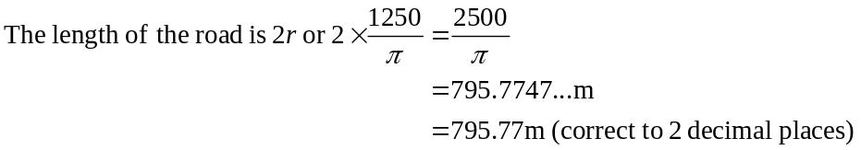
(1 mark)

- 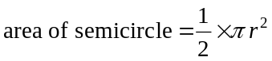
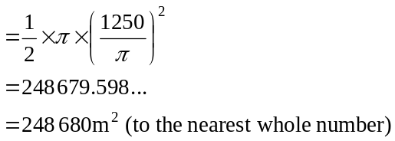
(1 mark)

Question 3 (3 marks)

- horizontal distance from point B to point L
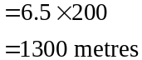

(1 mark)

- i. 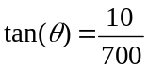
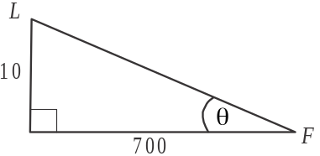
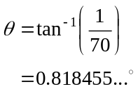
(1 mark)

- Using the diagram from part i. the average slope
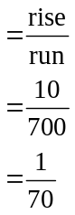
(1 mark)

Question 4 (6 marks)
- In ,
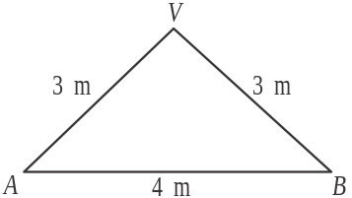
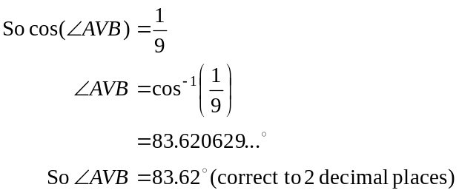
(1 mark)
- Start by finding the area of one of the 4 slant faces of the pyramid, eg. 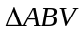.

Method 1 – using the sine formula for area
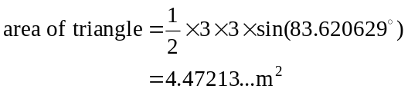
(1 mark)
Method 2 – using Heron’s formula
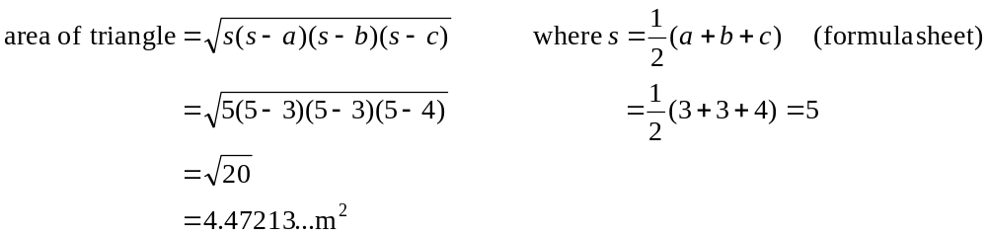 (1 mark)
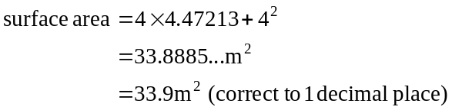
(1 mark)

- In
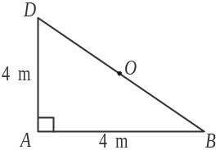
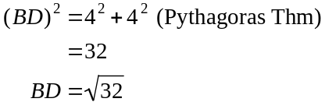
(1 mark)
In 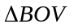, (O is the midpoint of BD and the
centre of the square base) OV is the height of the pyramid.
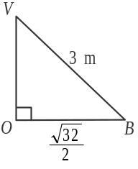
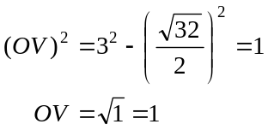
The height of the pyramid is 1 metre.
(1 mark)

- Ratio of side lengths is so the scale factor is 4.
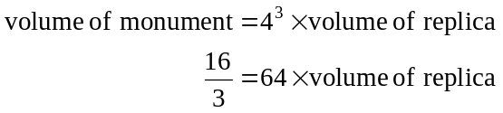
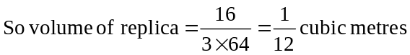 (1 mark)
Module 3: Graphs and relations.

Question 1 (5 marks)

- Rachel took her half hour break between . Since she started at 10am, this means she took her break between 12 noon and 12.30pm.
(1 mark)
- Before 12 noon, Rachel’s hourly pay was 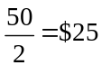 per hour.
(1 mark)
- The gradient of the graph after 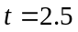 must be 30.
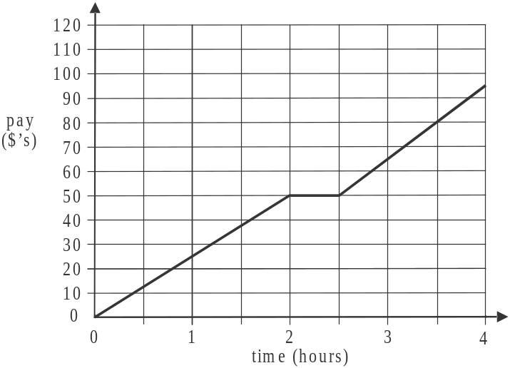

(1 mark)
- From part c., the line segment that we have drawn has the rule 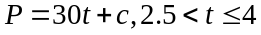.
We know this line segment passes through the point 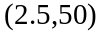.
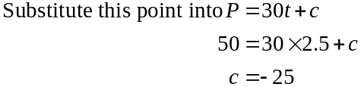
(1 mark)
e. 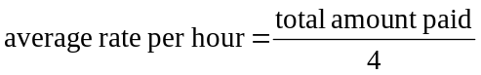
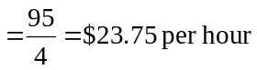 (1 mark)

Question 2 (2 marks)

- From the graph, it costs $20 for one item of clothing to be cleaned in 2 hours.
So, in total it will cost Jane 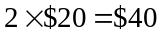.
(1 mark)
- Let x be the cost of cleaning an item in more than 30 minutes and less than or equal to 90 minutes.
Let y be the cost of cleaning an item in more than 210 minutes and less than or equal to 300 minutes.
For customer 1, 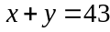
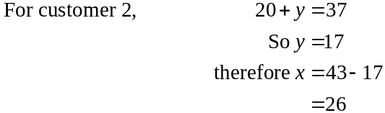
It costs $26 to have an item cleaned in one hour. (1 mark)
Question 3 (2 marks)
- 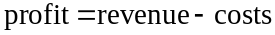
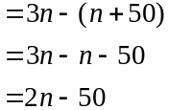
(1 mark)
- break even occurs when
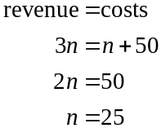
So 25 items need to be ironed for Clem to break even.
The person doing the ironing will earn 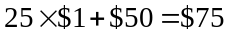 on such a day.
(1 mark)
Question 4 (6 marks)

- d represents the total staff time available in a day for cleaning rugs and doonas.
Note that d should be expressed in minutes. So .
(1 mark)
- (1 mark)
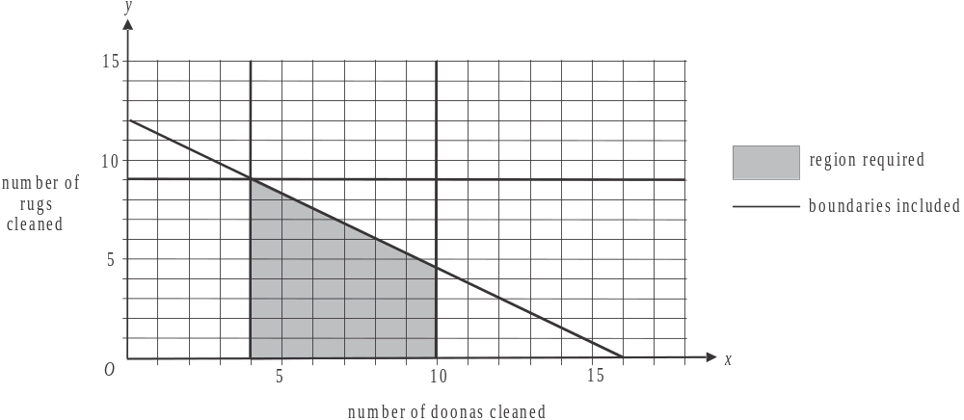

(1 mark)
- Looking at the graph, and remembering that you can only have whole doonas and whole rugs, the possible combinations of doonas and rugs that could give us a maximum value of T are located at
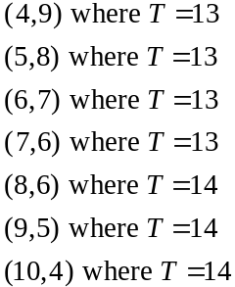
Note that points ‘beneath’ these points will have a smaller value of T e.g. (4,8), (4,7) etc.
The maximum value of T is 14 and three points offer this.
The point (10,4), has the largest number of doonas cleaned in a day.
The answer is 10 doonas. (1 mark)

- 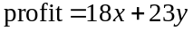
Check the points given in part d.
For
(Note that the points (4,8), (4,7), (4,6) etc will give less profit than the point (4,9) so just bypass them).
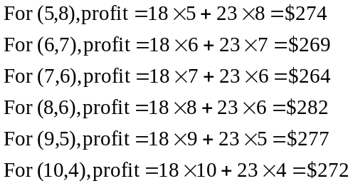
So the maximum profit Clem can make is $282.
(1 mark)

- Again using the points given in part e., the only one which has its y-coordinate (number of rugs) 3 greater than its x-coordinate (number of doonas) is the point (5,8).
So the maximum profit would be $274.
(1 mark)

Module 4: Business-related mathematics.

Question 1 (4 marks)

-  and 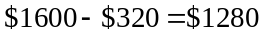
A customer would pay $1280 in cash. (1 mark)

- i. 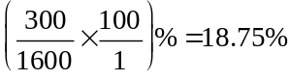 (1 mark)

There was $1300 owing after the deposit of $300 had been made so Ken paid 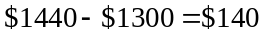 in interest. (1 mark)

- We use the simple interest formula 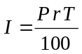 and rearrange it. The interest rate r , in this case is referred to as flat interest. Note that Ken repaid the loan in 24 monthly instalments so it took him 2 years to repay it so 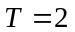.
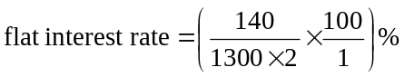
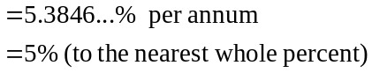
(1 mark)

Question 2 (4 marks)

- Phil receives $210 per quarter which is $840 per year.
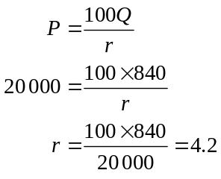
The annual interest rate is 4.2% per year. (1 mark)

- Use the compound interest formula.
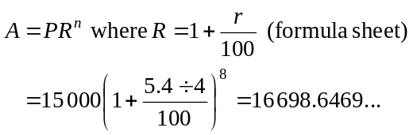
This investment is worth $16 698.65 after two years. (1 mark)
c. i. Because there are regular (quarterly) payments being made to this investment
we have an annuity investment so we use TVM.

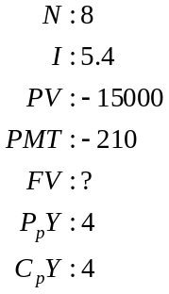
So after 2 years this investment will be worth $18 460.21 (1 mark)
Note that because this is an annuity where the investor keeps investing (rather than an annuity where the investor is paid regularly) the present value is negative (because you give the money to the bank to invest) and the payment is negative (again because you pay the bank regularly).
- From part c.i., Phil’s investment with the extra quarterly amount paid in is worth $18 460.21.
This includes in interest.
From part b. Phil’s investment without the extra quarterly amount paid in is worth $16 698.65.This includes 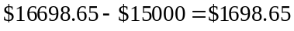 in interest.
So Phil would earn an extra 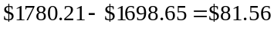 in interest.
(1 mark)

Question 3 (4 marks)

- i. 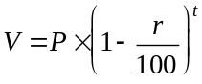
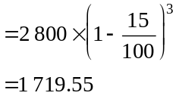
The depreciated value after 3 years is $1 719.55.
(1 mark)

- Half of the initial value of the dryer is 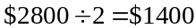.
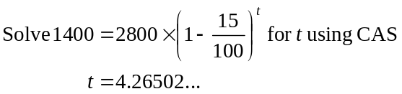
It takes 4.265 years (correct to 3 decimal places). (1 mark)

    - i. The flat rate method depreciates the dryer by the same amount each year; that is, by 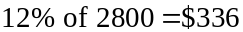.
It will take 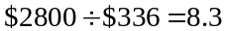 years (correct to 1 decimal place).
(1 mark)

- The unit cost method depreciates the dryer at 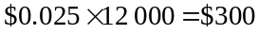 per year.
It will take 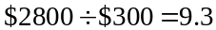 years (correct to 1 decimal place).
(1 mark)

Question 4 (3 marks)

- This is a reducing balance loan so use TVM.

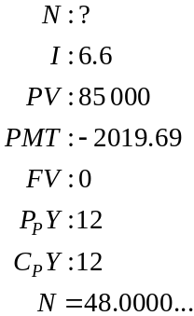
It takes 48 months or 4 years to fully repay the loan.
(1 mark)

- At the end of 2 years, the balance remaining can be found using TVM.

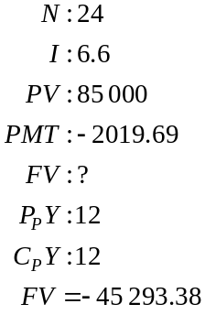
So there is $45 293.38 still owing two years into the original loan.
(1 mark)
Again using TVM find the monthly repayments needed to fully repay this in 12 months.

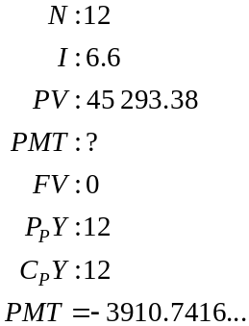
So Phil’s monthly payment will now be $3910.74.
(1 mark)
Module 5: Networks and decision mathematics

Question 1 (5 marks)

- From the diagram, 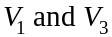 have odd degrees and the remaining vertices have even degrees. So there are 7 vertices (i.e. including the office) that have even degrees.
(1 mark)

- Using the diagram, and trial and error, the shortest distance is 250m (which can be along office, 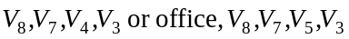).
(1 mark)

- The path followed by the gardener is an Euler path. An Euler path exists if the network has only two odd vertices which this network does at . So the gardener could have started at or finished at 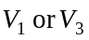.
(1 mark)

- The route followed by the resort manager starts and finishes at the office, so it is a circuit rather than a path. Also, it passes through each vertex just once. Therefore it is a “Hamiltonian circuit”.
(1 mark)

- The paths that are not closed should form a minimum spanning tree.
Start with the shortest edge (i.e. 45) and add the next shortest edge until all the vertices are connected.

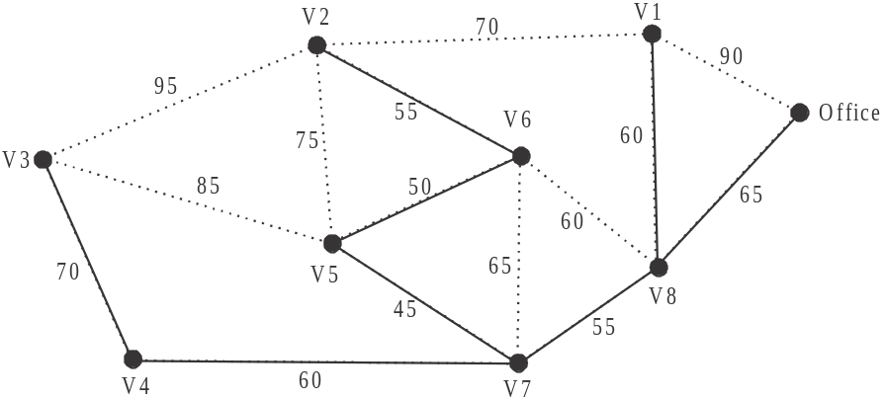

(1 mark)

Question 2 (6 marks)
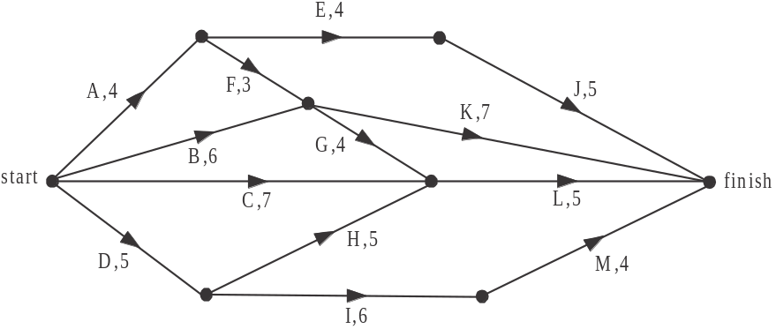

(1 mark)
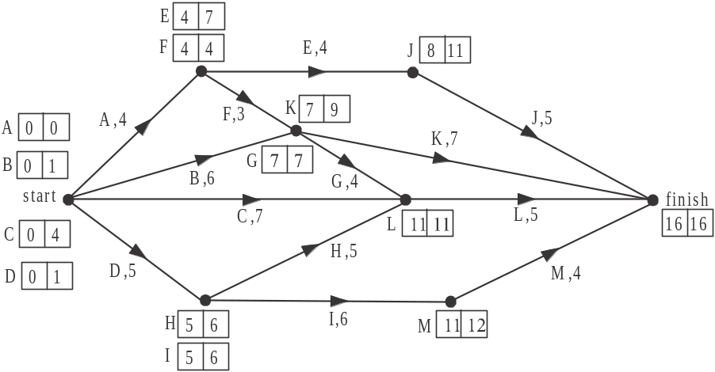

The earliest and latest start times for the tasks are shown above.
The earliest start time for task L is 11 hours.
(1 mark)
- Using the earliest and latest start times from the solutions in part b., the minimum time to complete the tasks is 16 hours.
(1 mark)
- Again using the solutions in part b., the task with the greatest slack (or float) time is task C which has a slack time of hours.
(1 mark)
e. The 8 possible paths on the diagram, together with their completion times before the crashing of G are:
A, E, J (13 hours)
A, F, K (14 hours)
A, F, G, L (original critical path) (16 hours)
B, K (13 hours)
B, G, L (15 hours)
C, L (12 hours)
D, H, L (15 hours)
D, I, M (15 hours)
By crashing activity G by 1 hour the minimum time that the project can be completed in is now 15 hours.
That is, the original critical path A, F, G, L, has been reduced by one hour to 15 hours.
The only other path that is affected by the crashing of G is B, G, L. Its completion time is now 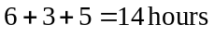. This means that 2 other paths emerge as critical with completion times of 15 hours. They are D, H, L and D, I, M.
So, the activities that are critical after the crashing are 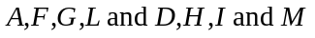.
(1 mark) - activities A, F, G and L (1 mark) – activities D, H, I and M
Question 3 (4 marks)

- We need to find the maximum capacity of the network. We do this by using trial and error to find the minimum cut.

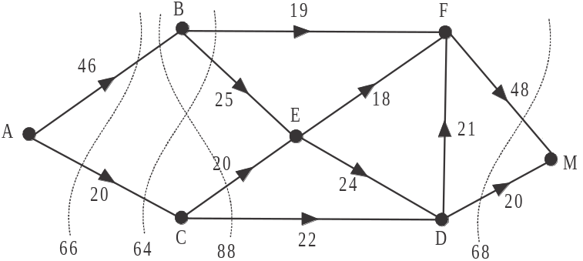

A few cuts are shown above. The minimum cut possible is 64. So a maximum of 64 tourists can be carried from island A to the mainland in a day.
(1 mark)

- Since the tour group of 21 tourists must travel the same route, they must travel to island B, then island E, then island D then island F then to the mainland.
The path in short is A, B, E, D, F, M.
(1 mark)

- Using the directed network given, show the capacity available after the 21 American tourists have been carried from island A to the mainland.

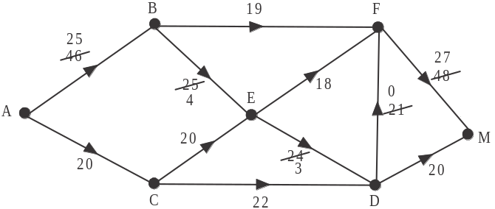

The next largest group that can travel the same route together contains 20 tourists. This must be the German group and the route it must travel is A, C, D, M.

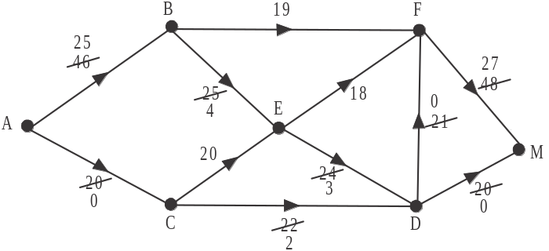

The next largest group that can travel the same route together contain 19 tourists. This must be the UK group and the route it must travel is A, B, F, M.
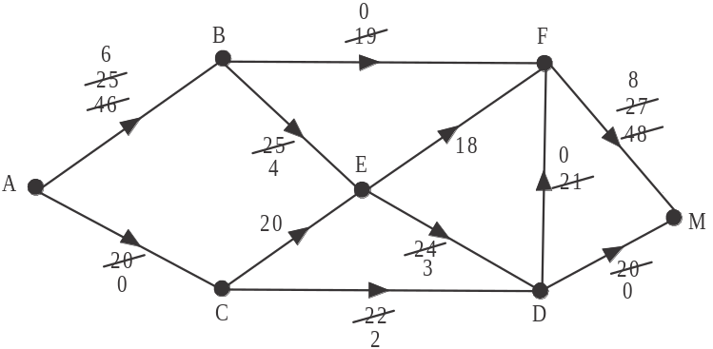

The next largest group (which is the last and smallest group) that can travel the same route together contains 4 tourists. This must be the Japanese group and the route it must travel is A, B, E, F, M.

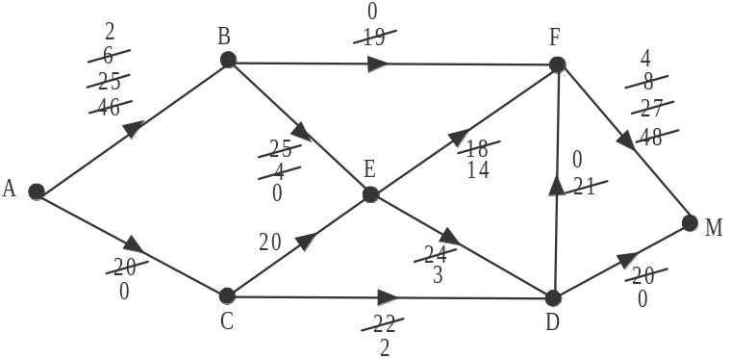

In summary, the table should look like:

 | Tour group nationality
 | American | German | UK | Japanese
maximum size | 21 | 20 | 19 | 4
route taken | (part b. answer) | A, C, D, M | A, B, F, M | A, B, E, F, M

Note that the total number of tourists is 64 – the maximum number found in part a.
(1 mark)- correct German entries
(1 mark) – remaining entries correct

Module 6: Matrices

Question 1 (3 marks)

- The order of matrix A is .
(1 mark)

- The sum of the elements in column 2 is 2. This means that area I is directly linked to two other areas, namely areas K and O.
(1 mark)

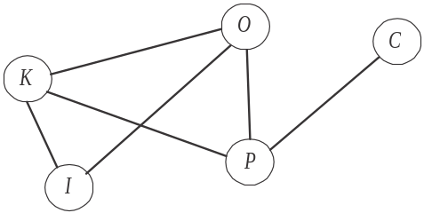

(1 mark)

Question 2 (9 marks)
- i.
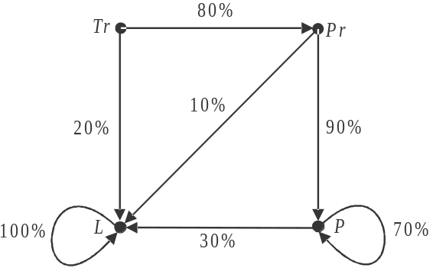

(1 mark) – 2 correct sides and percentages
(1 mark) – 3 more correct sides and percentages
- 80% of trainees go on to become probationary staff members each month.
At the start of 2013 there are 10 trainees 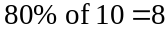.
So 8 trainees go on after one month into 2013.
(1 mark)
- i. 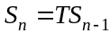
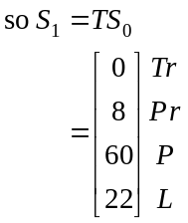
Use your calculator for this matrix multiplication. Define matrix T and matrix 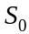 first. So at the end of the first month there are staff working (i.e. 22 have left).
(1 mark)
ii.
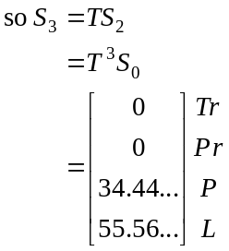
(1 mark)
Again use your calculator here. You should already have defined 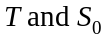.
iii. 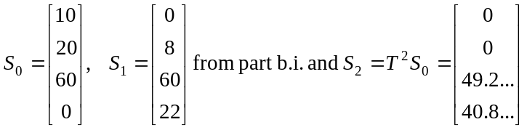
At the start of the year the owner had 10 trainee and 20 probationary staff. So during January he had these two categories of staff. At the end of January he had no trainee staff and 8 probationary staff. So during February he still had 8 probationary staff. By the end of February he had neither category. So for January and February only, the owner had trainee and/or probationary staff.
(1 mark)
iv. Using trial and error (and your calculator),
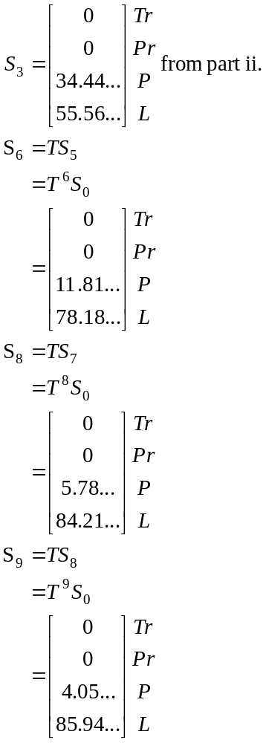
So during the ninth month in 2013; that is September, the number of permanent staff first dropped below five. (1 mark)

- 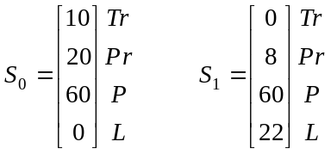
Comparing the state matrices for the start of January 2013 and the end of January 2013, we see that the owner would have to employ 10 trainee staff, 12 probationary staff and 0 permanent staff at the end of each month.
(1 mark) – 1 correct answer
(1 mark) – 2 additional correct answers

Question 3 (3 marks)

- 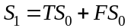
You should already have defined on your calculator as well as the product 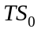 from Question 2 part b.i. Define F on your calculator.
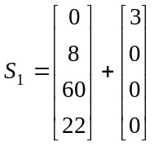

So 3 new trainee staff would be added in January 2013 according to this model.
(1 mark)

- 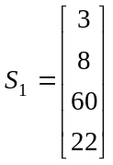 from part a.
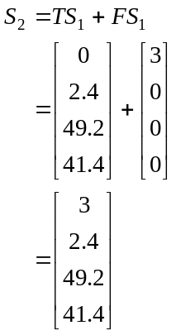
(1 mark)
So the number of probationary staff at the end of the second month in 2013 is 2 (correct to the nearest whole number).
(1 mark)

